**LAPORAN JOBSHEET 2**

**KONSEP DASAR PEMROGRAMAN**

Mata Kuliah : Algoritma dan Struktur Data

Dosen : **Mungki Astiningrum, S.T., M.Kom.**



**Alfreda Dhaifullah Mahezwara**

**244107020219**

**Kelas : 1A**

**Absen : 04**

**PROGRAM STUDI TEKNIK INFORMATIKA JURUSAN TEKNOLOGI INFORMASI POLITEKNIK NEGERI MALANG TAHUN 2025**

1. **Percobaan 1**

package Pertemuan_12;

public class Mahasiswa004 {

String nim;

String nama;

String kelas;

double ipk;

Mahasiswa004 () {

}

Mahasiswa004 (String nm, String name, String kls, double ip) {

nim = nm;

nama = name;

kelas = kls;

ipk = ip;

}

void tampilInformasi () {

System.out.println("NIM: " + nim + ", Nama: " + nama + ", Kelas: " + kelas + ", IPK: " + ipk);

}

}

package Pertemuan_12;

public class Node04 {

Mahasiswa004 data;

Node04 next;

public Node04 (Mahasiswa004 data, Node04 next) {

this.data = data;

this.next = next;

}

}

package Pertemuan_12;

public class SingleLindeklist04 {

Node04 head;

Node04 tail;

boolean isEmpty () {

return (head == null);

}

public void print () {

if (!isEmpty()) {

Node04 tmp = head;

System.out.println("Isi linked list:\t");

while (tmp != null) {

tmp.data.tampilInformasi();

tmp = tmp.next;

}

System.out.println("");

} else {

System.out.println("Linked list kosong");

}

}

public void addFirst (Mahasiswa004 input) {

Node04 ndInput = new Node04(input, null);

if (isEmpty()) {

head = ndInput;

tail = ndInput;

} else {

ndInput.next = head;

head = ndInput;

}

}

public void addLast (Mahasiswa004 input) {

Node04 ndInput = new Node04(input, null);

if (isEmpty()) {

head = ndInput;

tail = ndInput;

} else {

tail.next= ndInput;

tail = ndInput;

}

}

// untuk memasukan node yang memiliki data input setelah node yang memiliki data key

public void insertAfter (String key, Mahasiswa004 input) {

Node04 ndimput = new Node04(input, null);

Node04 temp = head;

do {

if (temp.data.nama.equalsIgnoreCase(key)) {

ndimput.next = temp.next;

temp.next = ndimput;

if (ndimput.next == null) {

tail = ndimput;

}

break;

}

} while (temp != null);

}

// method untuk menambahkan node pada indeks tertentu

public void insertAt(int index, Mahasiswa004 input) {

if (index < 0) {

System.out.println("Indeks salah");

} else if (index == 0) {

addFirst(input);

} else {

Node04 temp = head;

for (int i = 0; i < index - 1; i++) {

temp = temp.next;

}

temp.next = new Node04(input, temp.next);

if (temp.next.next == null) {

tail = temp.next;

}

}

}

}

package Pertemuan_12;

public class SLLMain04 {

    public static void main (String[] args) {

         // Membuat objek SingleLinkedList

         SingleLindeklist04 linkedList = new SingleLindeklist04();

         // Membuat empat objek Mahasiswa

         Mahasiswa004 mhs1 = new Mahasiswa004("123", "Alice", "A", 3.8);

         Mahasiswa004 mhs2 = new Mahasiswa004("124", "Bob", "B", 3.5);

         Mahasiswa004 mhs3 = new Mahasiswa004("125", "Charlie", "C", 3.9);

         Mahasiswa004 mhs4 = new Mahasiswa004("126", "Diana", "D", 3.7);

         // Menambahkan data ke linked list dan mencetak perubahan

         System.out.println("Menambahkan data mhs1:");

         linkedList.addFirst(mhs1);

         linkedList.print();

         System.out.println("\nMenambahkan data mhs2:");

         linkedList.addLast(mhs2);

         linkedList.print();

         System.out.println("\nMenambahkan data mhs3 setelah mhs1:");

         linkedList.insertAfter("Alice", mhs3);

         linkedList.print();

         System.out.println("\nMenambahkan data mhs4 ke akhir:");

         linkedList.addLast(mhs4);

         linkedList.print();

    }

}

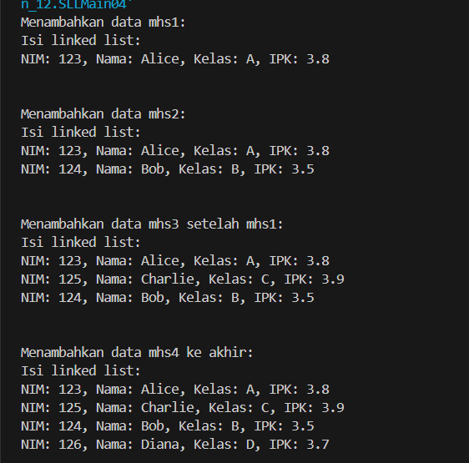

1. **Percobaan 2. Memodifikasi elemen pada single linked list**

inkedList.print();

System.out.println("data index 1 : ");

linkedList.getData(1);

System.out.println("data mahasisma an Binon berada pada index : "+linkedList.indexOf("binon"));

System.out.println();

linkedList.removeFirst();

linkedList.removeLast();

linkedList.print();

linkedList.removeAt(0);

linkedList.print();

public void getData(int index) {

Node04 tmp = head;

for (int i = 0; i < index; i++) {

tmp = tmp.next;

}

tmp.data.tampilInformasi();

}

public int indexOf(String key) {

Node04 tmp = head;

int index = 0;

while (tmp != null && !tmp.data.nama.equalsIgnoreCase(key)) {

tmp = tmp.next;

index++;

}

if (tmp == null) {

return -1;

} else {

return index;

}

}

public void removeFirst() {

if (isEmpty()) {

System.out.println("Linked List masih Kosong, tidak dapat dibapus!");

} else if (head == tail) {

head = tail = null;

} else {

head = head.next;

}

}

public void removeLast() {

if (isEmpty()) {

System.out.println("Linked List mashh Kosong, tidak dapat dihapus!");

} else if (head == tail) {

head = tail = null;

} else {

Node04 temp = head;

while (temp.next != tail) {

temp = temp.next;

}

temp.next = null;

tail = temp;

}

}

public void remove(String key) {

if (isEmpty()) {

System.out.println("Linked List masih Kosong, tidak dapat dibapus!");

} else {

Node04 temp = head;

while (temp != null) {

if ((temp.data.nama.equalsIgnoreCase(key)) && (temp == head)) {

this.removeFirst();

break;

} else if (temp.data.nama.equalsIgnoreCase(key)) {

temp.next = temp.next.next;

if (temp.next == null) {

tail = temp;

}

break;

}

temp = temp.next;

}

}

}

public void removeAt(int index) {

if (index == 0) {

removeFirst();

} else {

Node04 temp = head;

for (int i = 0; i < index - 1; i++) {

temp = temp.next;

}

temp.next = temp.next.next;

if (temp.next == null) {

tail = temp;

}

}

}

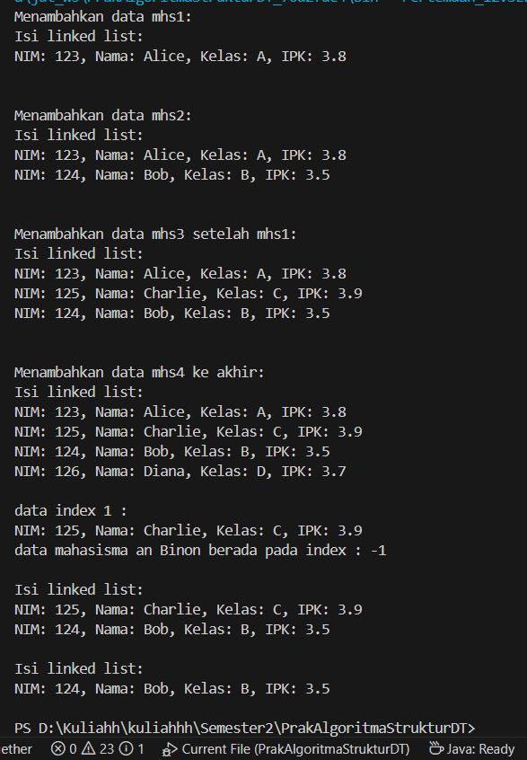

**TUGAS**

package Pertemuan_12;

import java.util.Scanner;

class Mahasiswa {

String nim;

String nama;

String jurusan;

public Mahasiswa(String nim, String nama, String jurusan) {

this.nim = nim;

this.nama = nama;

this.jurusan = jurusan;

}

void tampilData() {

System.out.println("NIM: " + nim);

System.out.println("Nama: " + nama);

System.out.println("Jurusan: " + jurusan);

}

}

class Node {

Mahasiswa data;

Node next;

public Node(Mahasiswa data) {

this.data = data;

this.next = null;

}

}

class AntrianKemahasiswaan {

private Node front;

private Node rear;

private int size;

private final int MAX_SIZE = 100; // Batas maksimal antrian

public AntrianKemahasiswaan() {

front = null;

rear = null;

size = 0;

}

// c. Cek antrian kosong

public boolean isEmpty() {

return front == null;

}

// d. Cek antrian penuh

public boolean isFull() {

return size == MAX_SIZE;

}

// d. Mengosongkan antrian

public void clear() {

front = null;

rear = null;

size = 0;

System.out.println("Antrian telah dikosongkan");

}

// e. Menambahkan antrian

public void enqueue(Mahasiswa mhs) {

if (isFull()) {

System.out.println("Antrian penuh! Tidak bisa menambahkan lagi.");

return;

}

Node newNode = new Node(mhs);

if (isEmpty()) {

front = newNode;

rear = newNode;

} else {

rear.next = newNode;

rear = newNode;

}

size++;

System.out.println("Mahasiswa " + mhs.nama + " telah ditambahkan ke antrian");

}

// f. Memanggil antrian

public Mahasiswa dequeue() {

if (isEmpty()) {

System.out.println("Antrian kosong!");

return null;

}

Mahasiswa mhs = front.data;

front = front.next;

if (front == null) {

rear = null;

}

size--;

System.out.println("Mahasiswa " + mhs.nama + " dipanggil");

return mhs;

}

// g. Menampilkan antrian terdepan

public void peekFront() {

if (isEmpty()) {

System.out.println("Antrian kosong!");

return;

}

System.out.println("Mahasiswa terdepan:");

front.data.tampilData();

}

// g. Menampilkan antrian paling akhir

public void peekRear() {

if (isEmpty()) {

System.out.println("Antrian kosong!");

return;

}

System.out.println("Mahasiswa terakhir:");

rear.data.tampilData();

}

// h. Menampilkan jumlah mahasiswa yang mengantre

public void jumlahAntrian() {

System.out.println("Jumlah mahasiswa yang mengantre: " + size);

}

// Menampilkan seluruh antrian

public void displayQueue() {

if (isEmpty()) {

System.out.println("Antrian kosong!");

return;

}

System.out.println("Daftar Antrian:");

Node current = front;

int no = 1;

while (current != null) {

System.out.print(no++ + ". ");

current.data.tampilData();

System.out.println("-------------------");

current = current.next;

}

}

}

class Main {

public static void main(String[] args) {

Scanner scanner = new Scanner(System.in);

AntrianKemahasiswaan antrian = new AntrianKemahasiswaan();

while (true) {

System.out.println("\n=== SISTEM ANTRIAN KEMAHASISWAAN ===");

System.out.println("1. Daftar Antrian");

System.out.println("2. Panggil Antrian");

System.out.println("3. Lihat Antrian Terdepan");

System.out.println("4. Lihat Antrian Terakhir");

System.out.println("5. Jumlah Antrian");

System.out.println("6. Tampilkan Semua Antrian");

System.out.println("7. Kosongkan Antrian");

System.out.println("8. Keluar");

System.out.print("Pilih menu: ");

int pilihan = scanner.nextInt();

scanner.nextLine(); // consume newline

switch (pilihan) {

case 1:

System.out.print("Masukkan NIM: ");

String nim = scanner.nextLine();

System.out.print("Masukkan Nama: ");

String nama = scanner.nextLine();

System.out.print("Masukkan Jurusan: ");

String jurusan = scanner.nextLine();

Mahasiswa mhs = new Mahasiswa(nim, nama, jurusan);

antrian.enqueue(mhs);

break;

case 2:

antrian.dequeue();

break;

case 3:

antrian.peekFront();

break;

case 4:

antrian.peekRear();

break;

case 5:

antrian.jumlahAntrian();

break;

case 6:

antrian.displayQueue();

break;

case 7:

antrian.clear();

break;

case 8:

System.out.println("Terima kasih!");

scanner.close();

System.exit(0);

default:

System.out.println("Pilihan tidak valid!");

}

}

}

}

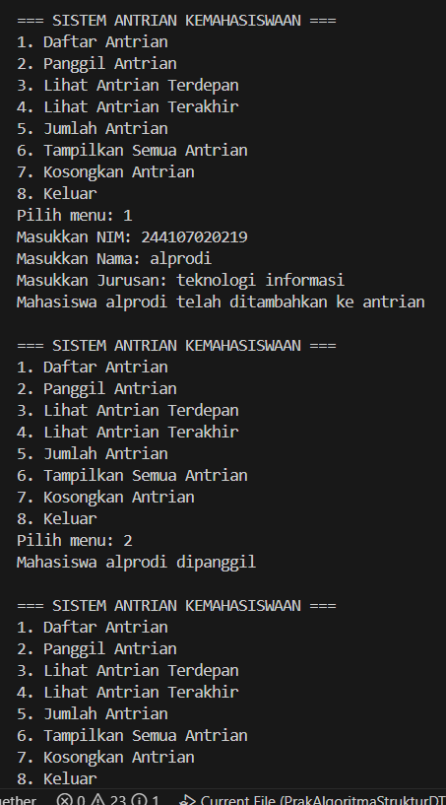 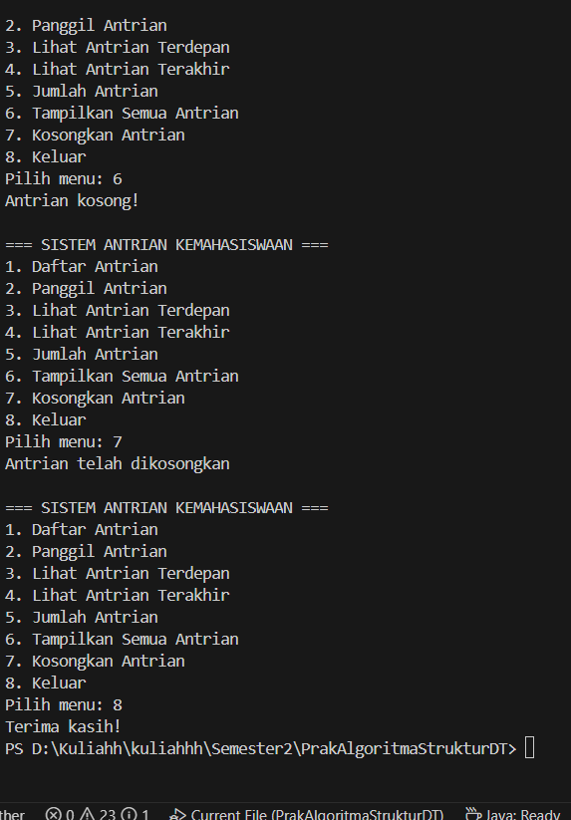

<https://github.com/AlfredaDhaifullah04/Semester-2/tree/master/Pertemuan_12>